**NAME: P.NITYASREE**

**REGNO: 17MIS1007**

**COURSE: INFORMATION SECURITY MANAGEMENT[CSE 3502]**

**FACULTY: ANUSHA**

**LAB EXERCISE-2 EXTENDED ACL**

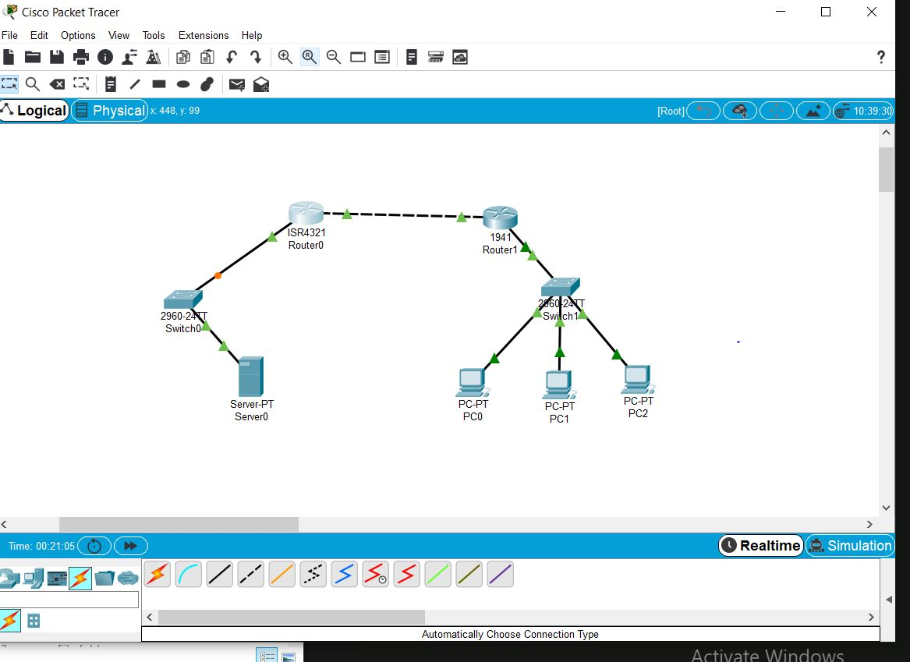

**RIP FOR ROUTER 0:**

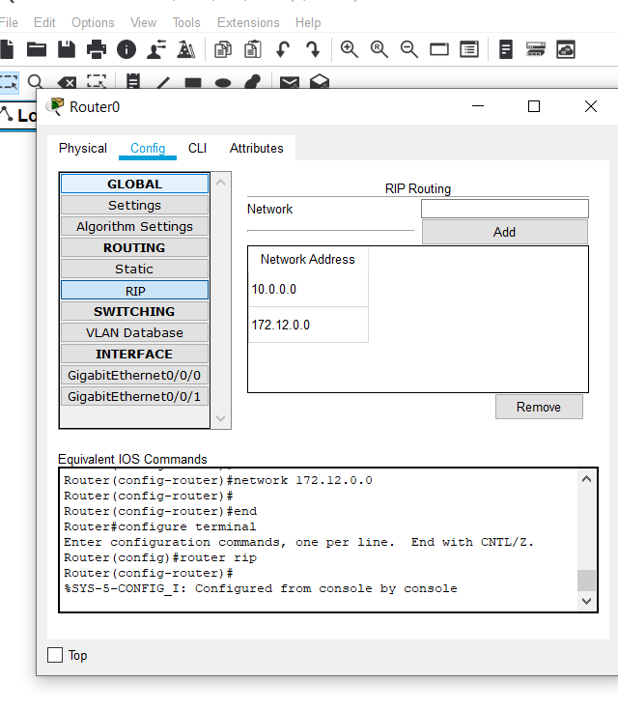

**RIP FOR ROUTER 1:**

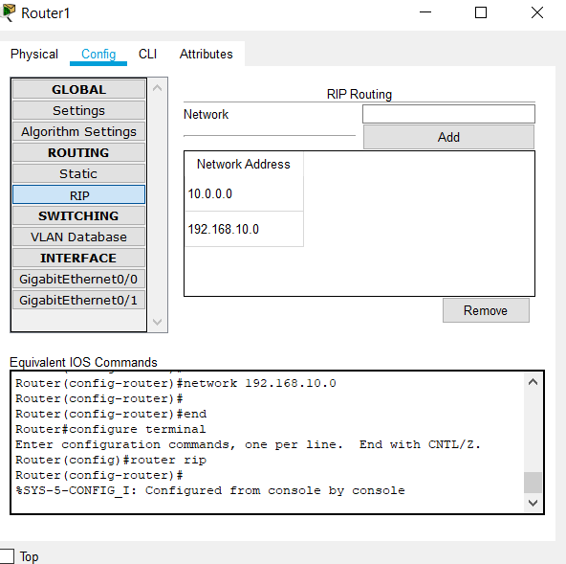

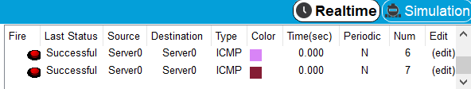

**EXTENDED ACL:**

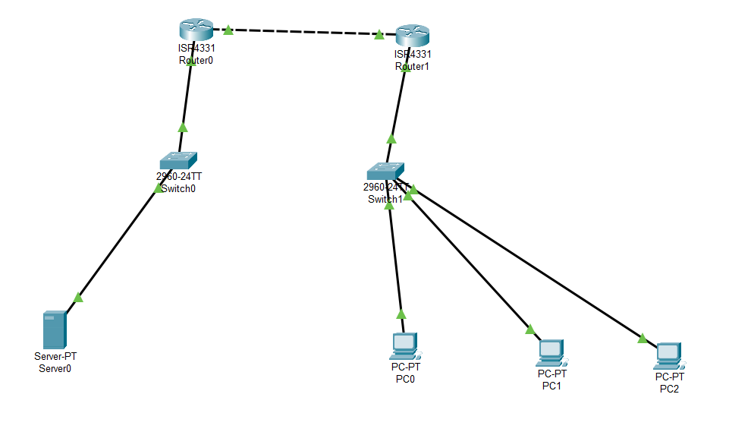

**Successful transfer of packets from Server to PC:**

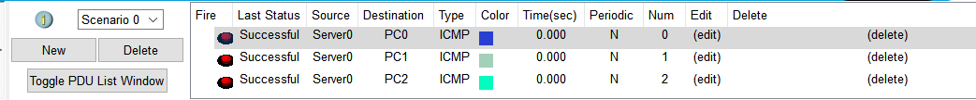

**Commands for Standard ACL Execution: In the router terminal (CLI)**

* **blocking the IP address 192.168.10.4 and server ip address 172.168.12.3**

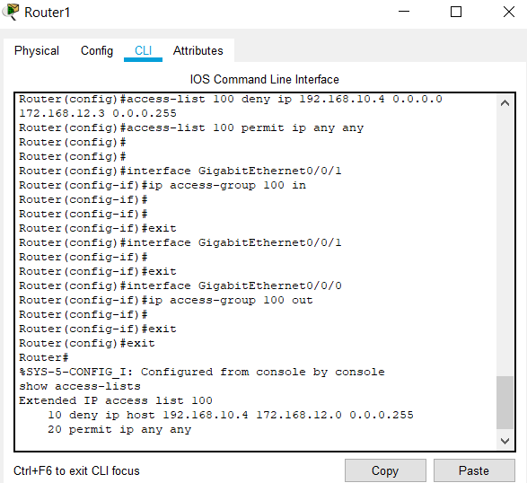

**Steps:**

* **First select an IP address of a particular PC that wanted to block it from the network and also the server IP address to block the packets from.**
* **Configure the inbound and outbound connections of a router.**
* **Finally, exit from the terminal and send the packets from the server to the blocked IP address then we can notice the failed package transfer.**

**Output with Extended ACL execution:**

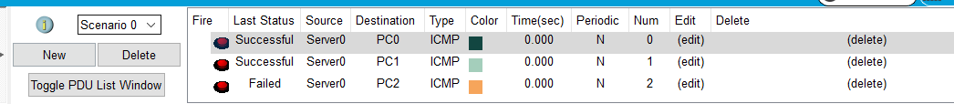

**We can infer that the PC 2 is blocked from receiving the packets which we can see in the output .**